

AL-Quds University
Faculty of Engineering
0700233
Engineering Mathematics Lab Project report
Project Name:Smart Ruler.
Team project Names: Wesam Fatafta, Yazan Ishtay.
Section: 1
Supervisors: Dr. Sana Iriqat.
ENG.Tarteel Sider.

Introduction
Accurate measurement of object dimensions from digital images is a common requirement in engineering, research, and various applied fields. However, obtaining reliable measurements depends on establishing a correct scale that converts pixel distances into real physical units. This scale varies with camera settings, distance, and perspective, making manual measurement both challenging and error-prone.
The Smart Ruler system provides a MATLAB-based graphical interface that enables users to measure object lengths directly from images with improved accuracy and convenience. The system now supports multiple calibration methods, including:
- a traditional manual reference, where the user selects two points on an object with a known length;
- a known-object reference method that uses predefined real-world dimensions of everyday items (such as credit cards, ID cards, batteries, or pens); and
- an automated AI-assisted method that detects an A4 sheet within the image and uses its known dimensions as a reference.
By combining interactive tools with basic image-processing techniques, the system offers a practical solution for users who need quick, consistent, and reliable measurements without requiring specialized equipment. The following sections describe the system’s components, workflow, and implementation details

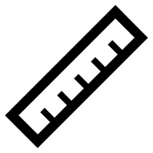


Background and Motivation
At the beginning of the project, we struggled to come up with a solid and practical idea. We were unsure about what types of projects would be acceptable for the course and how complex they were expected to be. To gain clarity, we met with Eng. Tarteel, who explained the general scope and limitations. Although her guidance was very helpful, we still had no concrete direction.
To broaden our search, we asked several classmates who had taken the course before, and we even reached out to people outside the university to collect more suggestions. Despite gathering many opinions, we still could not find an idea that matched our requirements. One of the main challenges was that our experience with MATLAB and image processing was very limited, meaning that any idea we chose had to build directly on concepts we had already learned in the original course labs. This was an essential condition, because choosing something beyond our skill level would make implementation unrealistic within the course timeline.
While looking for inspiration, we noticed that many students were relying heavily on “Ask ChatGPT” to generate ideas, but we preferred to explore more independent and thoughtful approaches. To try something different, we posted a question on Reddit asking for simple yet meaningful MATLAB project ideas. Unexpectedly, the post received significant engagement—over 11k views and nearly 50 replies—both public comments and private messages. This feedback helped shape our first potential idea: a voice selector using a MUX.
However, after analyzing the idea more deeply, we realized several limitations. The MUX-based approach relied on distinguishing voices using frequency information alone, which is unreliable because many speakers share overlapping frequency ranges. To make the system more accurate, we would need to identify speakers using richer vocal features, which would shift the project into a machine learning–based voice classification problem. This direction requires datasets, training models, and signal-processing techniques far beyond the expectations of the course. After discussing this with Eng. Tarteel, we confirmed that the idea was too complex to implement realistically.
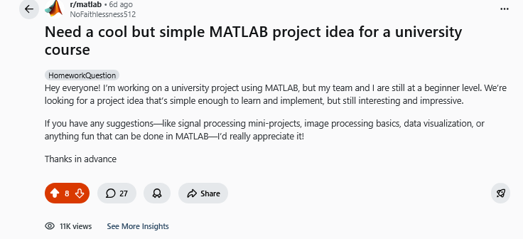
This pushed us to continue searching until we eventually arrived at the concept of the Smart Ruler. Unlike the previous idea, this project aligns directly with what we learned in the labs—such as image processing basics, geometry, and pixel measurements—making it both practical and achievable. The Smart Ruler offers meaningful functionality without unnecessary complexity, and it allowed us to apply the exact skills we developed during the course while still producing a useful and visually interactive tool
Figure 1) Reddit post used to crowdsource ideas for the project(

Problem Statement
After finalizing our project idea and deciding to move forward with the Smart Ruler concept, we identified the core problem that our system aims to address. In many real-world situations, users need to measure objects directly from digital images, but the relationship between pixel distances and actual physical units is not inherently defined. Without a proper reference or calibration method, such measurements become inaccurate and unreliable.
Traditional approaches often require controlled imaging environments, specialized equipment, or manual conversions that are inconvenient and prone to error—especially for users with limited technical background. Even when a reference object is present in the image, converting pixel distances into real-world lengths can be time-consuming and unintuitive.
Therefore, the main problem can be summarized as follows:
There is a clear need for a simple, accessible, and accurate tool that allows users to measure object lengths from images by establishing a reliable pixel-to-unit scale—whether through manual selection, predefined known objects, or automated detection methods—without requiring advanced image-processing skills.
The Smart Ruler project was developed to address this need by providing intuitive calibration options and a user-friendly measurement interface, enabling users to obtain accurate and consistent measurements from ordinary digital images
Objectives
After defining the problem and confirming the feasibility of the Smart Ruler idea, we established specific objectives to guide the project’s development. These objectives were shaped by both the limitations we faced during idea selection and the requirement that the project must be closely connected to concepts learned in the original MATLAB laboratory sessions.

1. Apply MATLAB concepts taught in the course labs
A key objective was ensuring that the project relied on the tools and skills introduced during the lab sessions. Given our limited experience, the system needed to utilize fundamental MATLAB concepts—such as scripts, functions, graphics, callback mechanisms, and basic image operations—rather than advanced external topics outside the course scope.
2. Develop a functional system capable of measuring real-world objects from images
The main goal was to create a tool that converts pixel distances into physical units. To achieve this, the system had to support multiple calibration methods that allow the user to define a reliable pixel-to-unit scale directly from the reference image.
3. Introduce flexibility through multiple calibration methods
In addition to manual calibration and A4-based calibration, we aimed to incorporate a known-object reference method that uses predefined real-world dimensions of common objects (e.g., credit cards, ID cards, AA batteries, pens, or phones). This greatly increases usability by giving the user more than one practical way to establish the measurement scale.
4. Choose a feasible and realistic idea based on our skill level
Because our experience with MATLAB and image processing was limited, we needed a project that we could realistically understand and implement. Our initial idea (a voice selector using a MUX) proved impractical due to overlapping voice frequencies and the need for machine-learning models to achieve meaningful accuracy. This highlighted the importance of selecting a simpler and more manageable idea aligned with our coursework.
5. Design an intuitive and user-friendly graphical interface (GUI)
Another objective was to build a clear and accessible GUI that enables users to load images, select calibration methods, measure object lengths, undo mistakes, and view results efficiently. The interface needed to guide the user through the steps without requiring technical expertise.
6. Implement an automated A4 detection method
We aimed to incorporate a semi-AI component capable of identifying an A4 sheet within the reference image and using its known dimensions to automatically determine the pixel-to-unit ratio. This reduces manual effort and enhances measurement convenience in controlled setups.
7. Ensure accuracy, reliability, and practical usefulness
The final objective was to deliver a tool that produces consistent and accurate measurements. The Smart Ruler was intended not only as a programming task but as a practical and meaningful application that demonstrates the usefulness of basic image-processing and geometric principles in a real-world context

Methodology
The Smart Ruler system follows a structured workflow that integrates graphical user interfaces, basic image-processing techniques, and geometric computations to enable accurate measurement of object lengths from digital images. The methodology describes how the system loads images, establishes a reference scale using one of several calibration methods, and performs real-world measurements using pixel information extracted from the images.

1. Graphical User Interface (GUI) Construction
The system begins by creating a MATLAB figure window that contains:
- A reference image display panel
- A measurement image display panel
- Interactive buttons for loading images, selecting calibration methods (manual reference, known-object reference, or A4 detection), measuring objects, undoing measurements, clearing results, and resetting the workspace
- A status text area that guides the user through the steps (Step 1/4 → Step 4/4)
- A dynamic results table for storing all recorded measurements
This design leverages MATLAB GUI concepts—such as figure, axes, imshow, uicontrol, and callback functions—which are consistent with the tools learned in the laboratory manual.
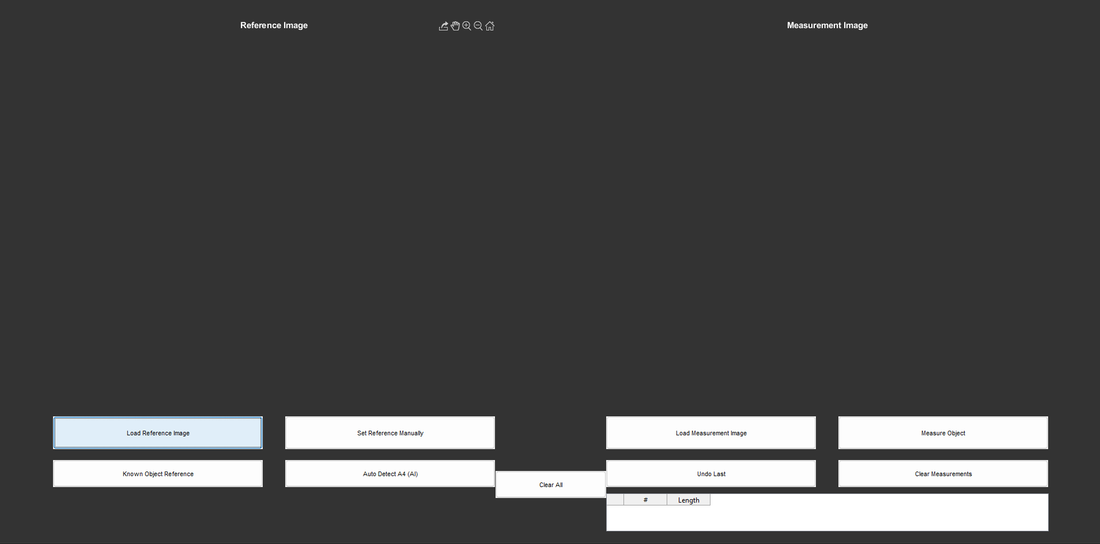
Figure 2
2. Loading the Reference Image
When the user selects Load Reference Image, the system:
- Opens a file-selection dialog using uigetfile.
- Reads the image using imread.
- Displays it in the reference panel using imshow.
- Resets previous calibration data to ensure accurate scaling.
This step initializes the workspace and prepares the environment for selecting a reference scale.
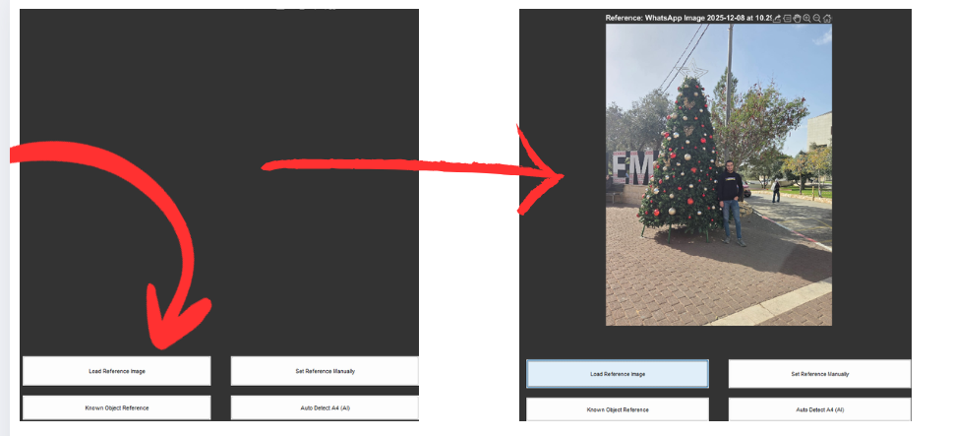
Figure 3
3. Manual Reference Calibration
In the Set Reference Manually mode:
- The user clicks two points on a known-length object using ginput.
- The system computes the pixel distance using the Euclidean formula:
$$d_{\text{pixels}}=\sqrt{\left(x_{2}-x_{1})^{2}+(y_{2}-y_{1})^{2}\right.}$$
- A dialog prompts the user to enter the real-world length and its unit.
- The scale factor is computed as:
$$\text{pixelsPerUnit}=\frac{d_{\text{pixels}}}{\text{realLength}}$$
- This value becomes the basis for all subsequent measurements.This approach demonstrates geometric principles and interactive MATLAB operations that align with the laboratory content.
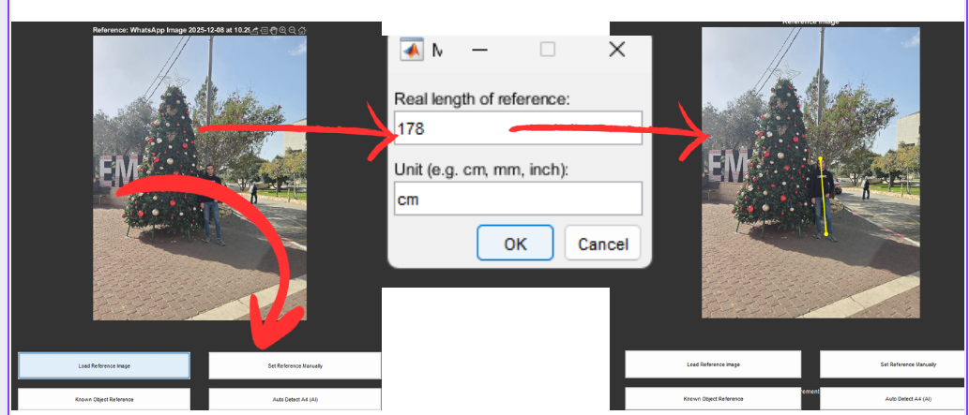
Figure 4
4. Known-Object Reference Calibration
In addition to manual calibration, the system supports selecting a reference from a database of predefined real-world objects, such as:
- Credit card / ID card
- AA battery
- Pen
- Phone
- A4 short side
The workflow is:
- The user chooses a known object from a list.
- The system prompts the user to click two points along that object.
- The pixel distance is computed.
- The real-world length is automatically retrieved from the database.
- The pixel-to-unit conversion factor is calculated.
This method improves usability when a common object with known dimensions is present in the reference image.
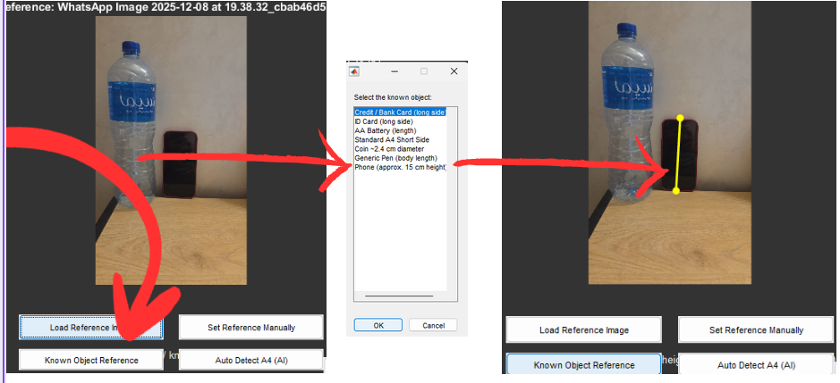
Figure 5
5. Automatic A4 Sheet Detection (AI-Assisted Calibration)
The Auto Detect A4 (AI) mode automates the calibration process:
- The reference image is converted to grayscale.
- A threshold (Otsu + upper bound) is applied to isolate bright regions.
- Morphological operations (imfill, imopen) remove noise.
- regionprops identifies large rectangular regions.
- Each region’s aspect ratio is compared to the A4 ratio:
$$\frac{29.7}{21}$$
- Once an A4-like rectangle is detected, its shortest side in pixels is mapped to 21 cm, giving:
$$\text{pixelsPerUnit}=\frac{\text{shortSidePixels}}{21}$$
This provides a fast and convenient calibration method when an A4 sheet is visible. 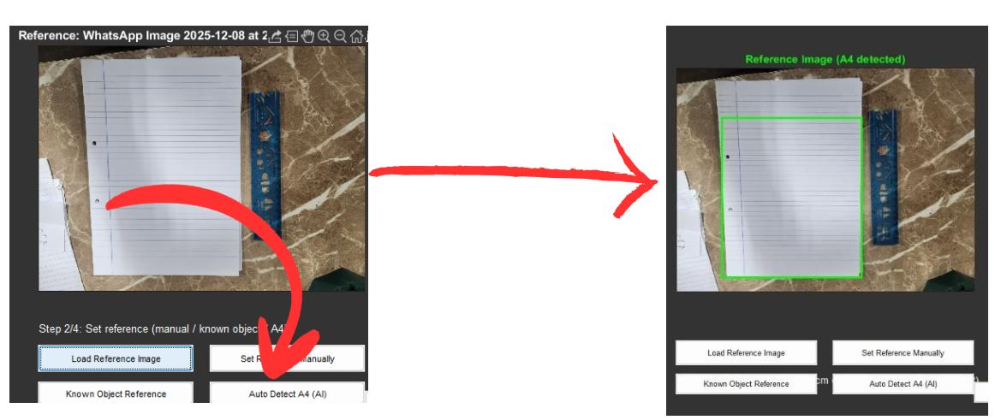
Figure 6
6. Loading the Measurement Image
Once calibration is set:
- The measurement image is loaded and displayed.
- Previous measurements are cleared from the display and table.
- The system prompts the user to begin measuring.
This step ensures a clean workspace before starting measurements.
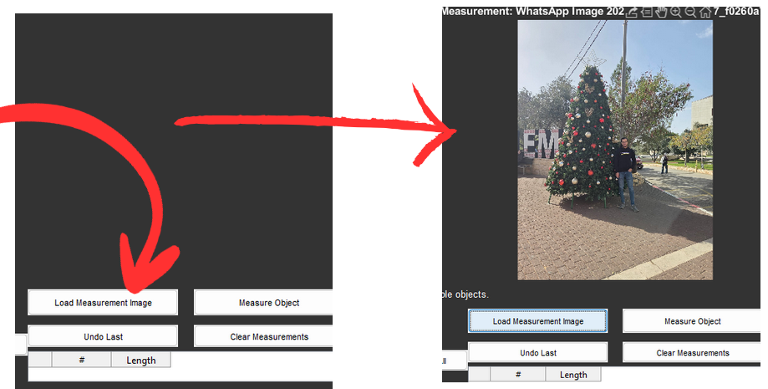
Figure 7
7. Object Measurement Procedure
When Measure Object is selected:
- The user clicks two points on the object being measured.
- Pixel distance is computed using the Euclidean formula.
- The physical distance is calculated:
$${\text{distance}}_{\text{units}}=\frac{d_{\text{pixels}}}{\text{pixelsPerUnit}}$$
- The system draws a colored line on the measurement image.
- A label displaying the measurement index and value appears at the midpoint.
- The measurement is added to the results table.
- Additional measurements can be made without resetting the image.
This step demonstrates the application of interactive graphics, callbacks, and geometric computations. 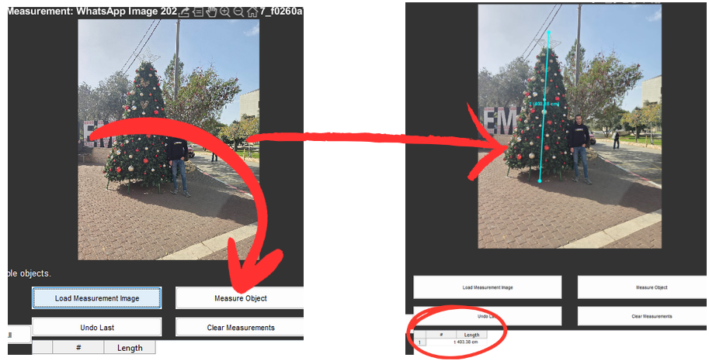
Figure 8
8. Undoing and Clearing Measurements
The updated system includes two additional features:
- Undo Last: Removes the most recent measurement, including its line, label, and table entry.

- Clear Measurements: Removes all measurements from both the image and the results table.
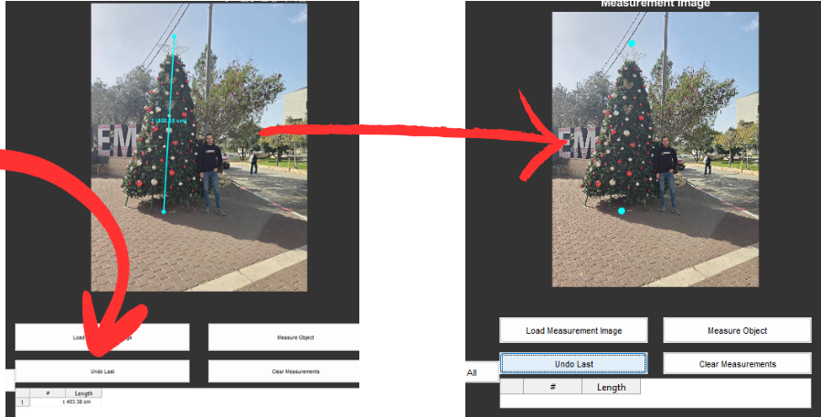
Figure 9
These tools improve usability and allow error correction without restarting the entire workflow.
9. Resetting the System
The Clear All button resets the entire interface:
- Images
- Calibration values
- Measurement lines and labels
- Results table
This allows the system to be reused cleanly for new measurement tasks.
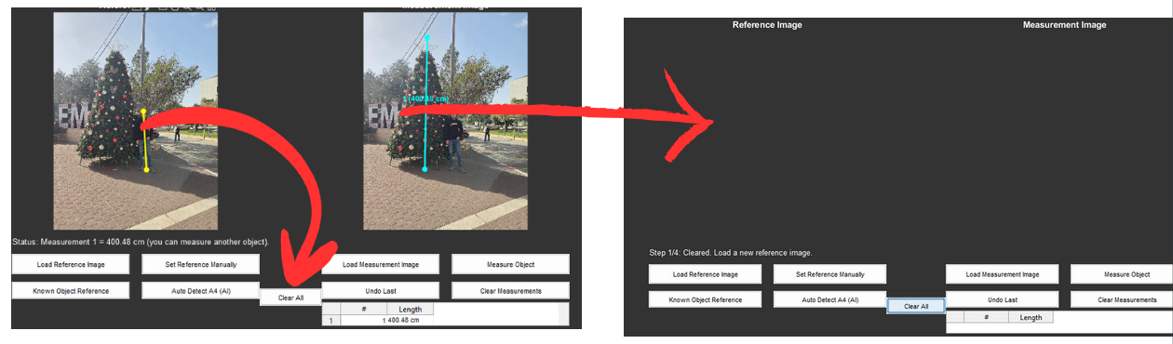
Figure 10
Summary of Workflow
- Load reference image
- Select calibration method:
  - Manual
  - Known Object
  - A4 AI detection
- Compute pixel-to-unit scale
- Load measurement image
- Click two points to measure objects
- View and record the real-world distance
- Undo, clear, or repeat as needed
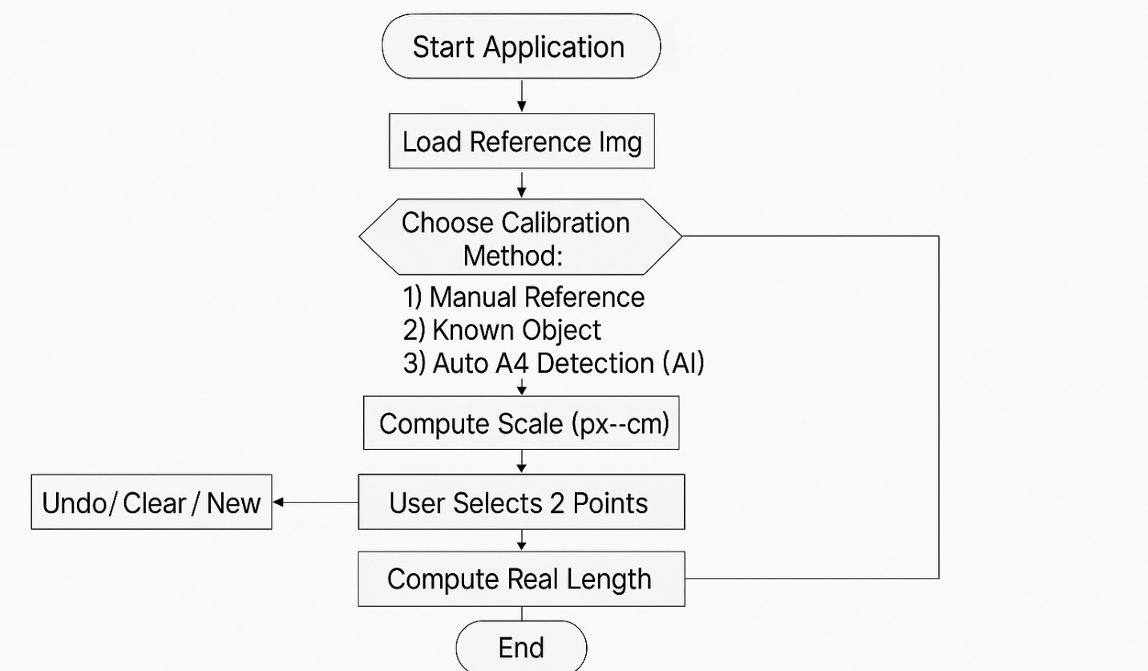
Figure 11

Results and Validation
The Smart Ruler system was tested using multiple images and different calibration methods. Visual inspection and practical measurements demonstrated consistent behavior and reliable scaling across typical use cases. Due to the interactive and graphical nature of the system, detailed measurement demonstrations and accuracy evaluation are presented during the project presentation.

Future Work
Although the Smart Ruler system successfully provides accurate measurements through manual reference, known-object calibration, and automated A4 detection, several enhancements can further improve its performance, robustness, and usability. The following ideas represent realistic and meaningful future improvements:
1. Support for Angle Measurement
Future versions can include a feature to measure angles between lines or edges.
This would expand the tool beyond simple linear measurements, making it useful for mechanical design, architectural drawings, and geometric analysis.

2. Multi-Point and Polygon Measurements
Allowing the user to select multiple points would enable the system to:
- Measure object perimeters
- Compute areas of shapes
- Extract profiles of irregular objects
This transforms the ruler into a more general geometric analysis tool.
3. Automatic Object Recognition for Reference Scaling
Integrating machine learning could allow the system to automatically recognize objects such as:
- Credit cards
- Mobile phones
- Coins
- Pens
This would eliminate the need for manual point selection and improve ease of use.
4. Improved A4 Detection Using Deep Learning
Current A4 detection relies on brightness thresholding and aspect ratio.
A future version could replace this with a deep-learning model such as YOLO or Mask R-CNN for more accurate performance in challenging lighting or cluttered backgrounds.
5. Real-Time Measurement Using a Webcam
Support for live webcam input would allow the tool to act as a real-time digital ruler.
Users could hold an object in front of the camera and measure it instantly.
6. Exporting Measurements and Reports Automatically
A professional enhancement would include:
- Exporting all measurements to PDF, Excel, or text files
- Saving screenshots automatically
- Generating a formatted measurement report
7. Curve and Contour Measurement
Future versions can allow users to measure curved objects by selecting multiple points and fitting splines.
This expands the program into applications like medical imaging and industrial inspection.
8. Automatically Detecting the Longest Edge of an Object
Instead of requiring users to click two points, the software can automatically detect:
- Object edges
- Corners
- Feature boundaries
Using Canny edge detection or Hough transforms
Limitations
Although the system performs reliably under typical conditions, several limitations were identified during development and testing:
1. Sensitivity to Image Quality
Measurements depend heavily on image clarity, lighting, and focus. Blurry or low-resolution images reduce the accuracy of point selection and reference detection.

2. A4 Detection Reliability
The A4 detection method uses thresholding and geometric filtering. This approach may fail when:
- the paper is partially occluded,
- the background is also bright,
- shadows distort the rectangular shape,
- the paper is rotated at extreme angles.
A more advanced detection model would be required for consistently robust performance.
3. Perspective Distortion
Objects photographed at an angle introduce perspective distortion, making straight lines appear shorter. The current system assumes the object lies in a flat plane parallel to the camera.
4. Manual Interaction Required
Even with zoom assistance, point selection still depends on the user’s precision. Human error can introduce variation in measurement results.
5. Limited Object Types in the Database
The known-object reference method relies on a simple database of predefined items. Only objects with standard, fixed dimensions can be used reliably.
6. No Support for Non-Linear or Curved Measurements
The system currently measures straight-line distances only. Curved paths or irregular shapes are not supported.
These limitations highlight opportunities for future improvement in automation, detection robustness, and measurement versatility.

Relation to Course Material
The Smart Ruler software incorporates several fundamental MATLAB concepts that were explicitly taught in the Engineering Mathematics Lab. The following points summarize the key manual concepts and how they appear in the project:
• Use of Matrices and Image Representation
- The manual explains that MATLAB stores data—including images—as matrices.
- The project uses this concept when handling reference and measurement images as numerical arrays for cropping, indexing, and computing pixel distances.
• MATLAB Graphics and Plotting Tools
- The manual introduces basic graphics commands such as figure, axes, and plot.
- The Smart Ruler applies these concepts by:
  - Displaying images with imshow.
  - Drawing measurement lines and markers.
  - Updating titles, overlays, and GUI elements visually.
• Script Files and User-Defined Functions
- The manual emphasizes modular programming using functions.
- The project implements several organized functions such as:
  - pickTwoPointsWithZoom() for precise point selection.
  - detectA4BoundingBox() for automatic reference detection.
  - getKnownObjectsDb() for predefined reference objects.
- Each function addresses a specific task, reflecting the structured coding approach taught in the manual.
• Flow Control Structures (if / else / loops)
- The manual teaches logical decision-making and loop mechanisms in MATLAB.
- The project uses these structures extensively to:
  - Validate inputs and user steps.
  - Ensure a proper workflow (reference → scale → measure).
  - Repeat deletion of graphics elements safely through loops.
• User Interaction and Input Handling
- The manual covers basic input techniques and interactive MATLAB behavior.
- The project applies this through:
  - Dialog boxes like inputdlg and listdlg.
  - GUI callbacks for buttons.
  - Interactive point-picking with crosshair zooming.
• Mathematical Computations
- The manual highlights using MATLAB for mathematical problem-solving.
- Smart Ruler applies these concepts through:
  - Using Euclidean distance formulas to calculate pixel differences.
  - Converting between pixels and real-world units.
  - Evaluating geometric ratios (A4 aspect ratio).

• Basic Computer Graphics Concepts
- The manual introduces how objects can be represented and drawn graphically.
- The project applies this by overlaying:
  - Measurement lines
  - Markers
  - Text labels
  - Bounding boxes on images

Conclusion
The Smart Ruler project successfully demonstrates how fundamental image-processing techniques and MATLAB GUI tools can be combined to create a practical and user-friendly measurement system. By implementing three calibration methods—manual reference selection, known-object calibration, and semi-automated A4 detection—the system enables users to convert pixel distances into real-world units with improved accuracy and convenience. The GUI design provides a clear workflow that guides the user through loading images, setting a reference scale, and performing measurements with minimal technical background.
The project achieved its main objective: creating an accessible measurement tool based strictly on concepts covered in the Engineering Mathematics Lab. In addition, the development process improved our understanding of geometric computations, interactive graphics, user interface design, and problem-solving using MATLAB. Overall, the Smart Ruler proves that even simple image-processing approaches can deliver practical value when combined with careful design, validation, and usability considerations

References
[1] MATLAB Documentation – Image Processing Toolbox
Official reference for functions like rgb2gray, regionprops, and morphological operations.

[2] MATLAB Documentation – Graphics and Plotting
Covers figure, axes, plot, imshow, and handling graphics objects.
[3] MATLAB App Building / GUI Development
Documentation on callbacks, UI components, and interactive graphics.

[4] Gonzalez, R. C., & Woods, R. E. – Digital Image Processing (4th Edition)
A leading reference for thresholding, filtering, and edge detection.
[5] Otsu Thresholding – N. Otsu, IEEE Transactions
Foundational method used conceptually for your binary segmentation step.
[6] J. Canny – A Computational Approach to Edge Detection
Classic paper on edge detection relevant to A4 detection discussions.
[7] Suzuki & Abe – Border Following Algorithm (regionprops foundation)
Method behind connected component extraction used by MATLAB.
[8] ISO 216: Paper Sizes (A4 Dimensions Standard)
Official reference for A4 paper dimensions (21 × 29.7 cm).
[9] MATLAB: Distance Between Two Points / Euclidean Distance
Documentation illustrating mathematical functions used in your measurement.
[10] MATLAB: User Input Functions (inputdlg, listdlg, uigetfile)
Reference for all GUI input methods used in your program.
https://www.mathworks.com/help/matlab/ref/inputdlg.html
https://www.mathworks.com/help/matlab/ref/listdlg.html
https://www.mathworks.com/help/matlab/ref/uigetfile.html

